Learning Activity Report Week 2: Windows Task Automation

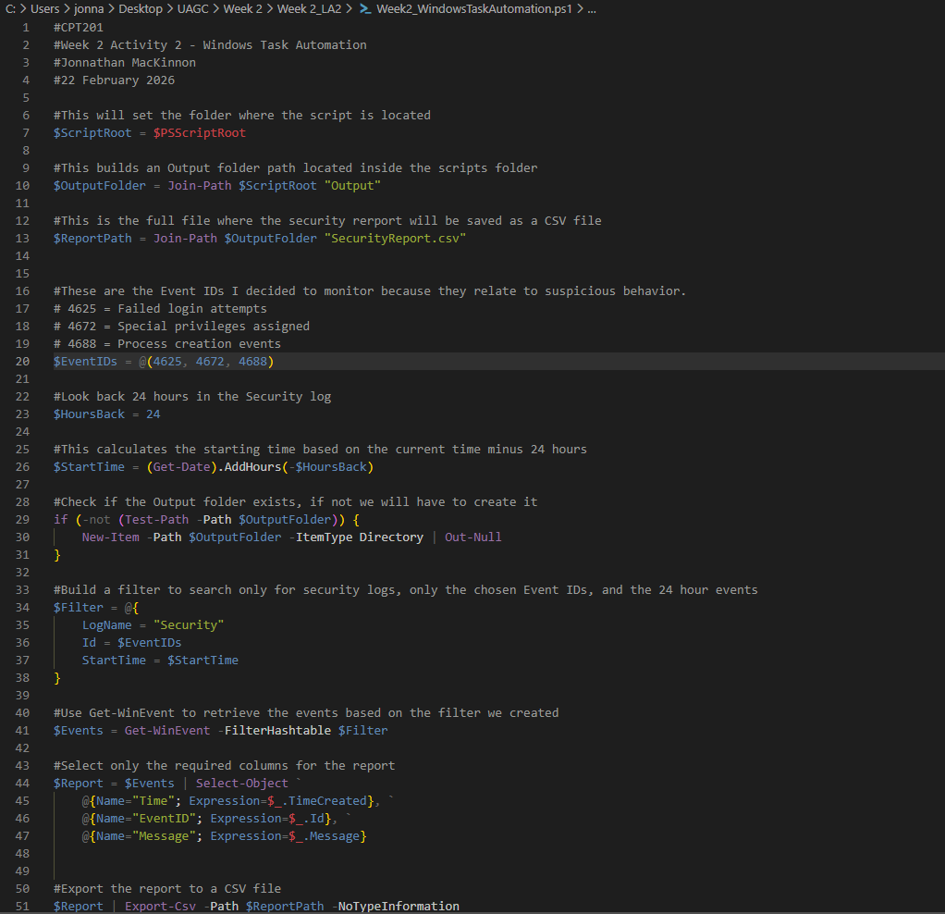
PowerShell Script (1 of 2):

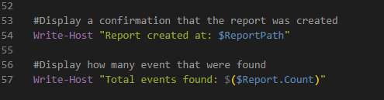
PowerShell Script (2 of 2):

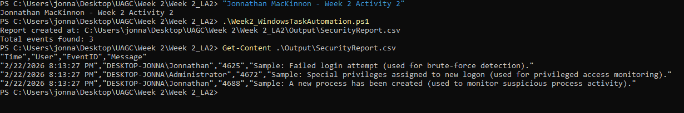
PowerShell Automation Results:

Reflection:
This activity helped me better understand how automation can be used for security monitoring instead of just administrative tasks. Before this, I mostly thought of PowerShell as a tool for managing systems, but now I see how it can support cybersecurity operations. By filtering specific event IDs such as the 4625 (failed logins), 4672 (special privileges assigned), 4688 (process creation events) IDs, I was able to just focus on those events instead of scouring through 100s of different potential issues within the system. I ended up figuring how to create a “fake IDs” to actually show the exact errors. These are all important indicators when looking for Brute-Force attempts or insider threats.
One thing that I really liked was how much easier it is to review logs when they are exported into a CSV file. Instead of manually digging through the Event Viewer or something, the script can narrow the results down and organize them into something readable. Automation should reduce human error and save a ton of time allowing the cyber security professionals to get other more important tasks done.

